MAWLANA BHASHANI SCIENCE AND TECHNOLOGY UNIVERSITY
SANTOSH, TANGAIL-1902



DEPARTMENT OF INFORMATION AND COMMUNICATION TECHNOLOGY
Lab Report

Lab Report No : 07
Lab Report on : Design and analysis of FIR digital filters using window techniques.
Course Title : Digital Signal Processing Lab
Course Code : ICT-3206

Submitted By | Submitted To
Name: Kuldip Saha Mugdha  ID: IT-22018  3rd Year, 2nd Semester  Session: 2021-2022  Dept. of ICT, MBSTU | Dr. Mst. Nargis Akter  Professor  DEPARTMENT OF INFORMATION AND COMMUNICATION TECHNOLOGY  MAWLANA BHASHANI SCIENCE AND TECHNOLOGY UNIVERSITY

Date of Performance: 12/01/26 Date of Submission: 17/01/26
Introduction:
FIR filters are always stable and have linear phase characteristics, making them suitable for many DSP applications. Window techniques such as Rectangular, Bartlett, and Hamming windows are commonly used to design FIR filters. This experiment demonstrates FIR filter design using different window functions.

Objective:
- To design a high-pass FIR filter using a Rectangular window.
- To design a low-pass FIR filter using a Bartlett window.
- To design a band-stop FIR filter using a Hamming window.

Theory:
- FIR filters have finite impulse responses and guaranteed stability.
- Window method truncates the ideal impulse response to obtain practical FIR filters.
- Different windows affect the transition band and ripple characteristics.

MATLAB Code:
Program 1: FIR High-Pass Filter Using Rectangular Window
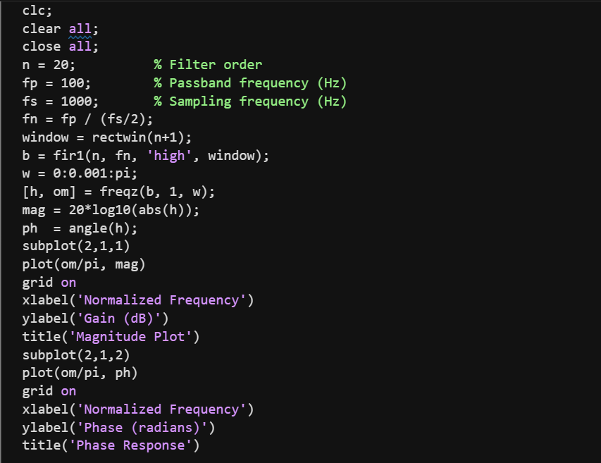

Output:
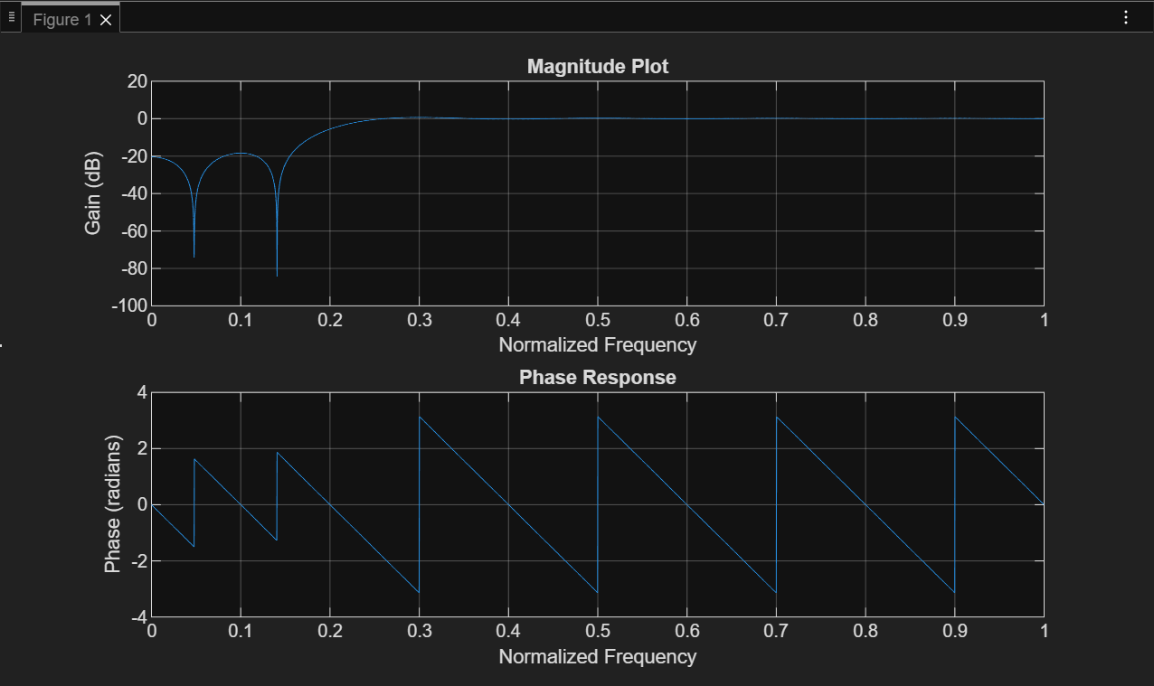
Program 2: FIR Low-Pass Filter Using Bartlett Window
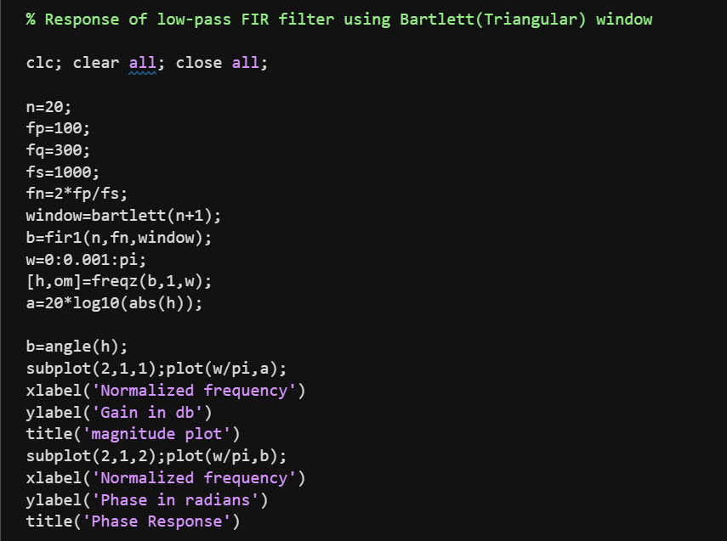
Output:
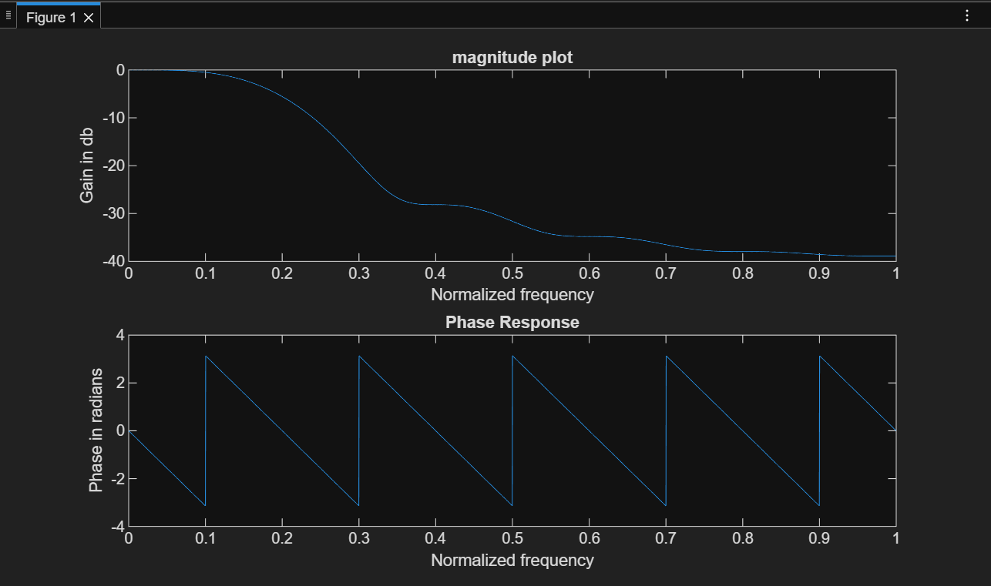
Program 3: FIR Band-Stop Filter Using Hamming Window
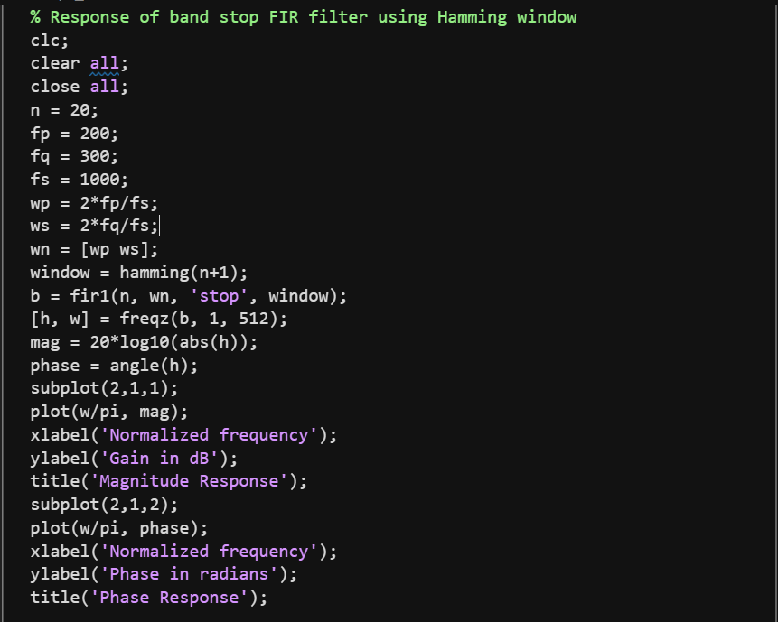
Output:
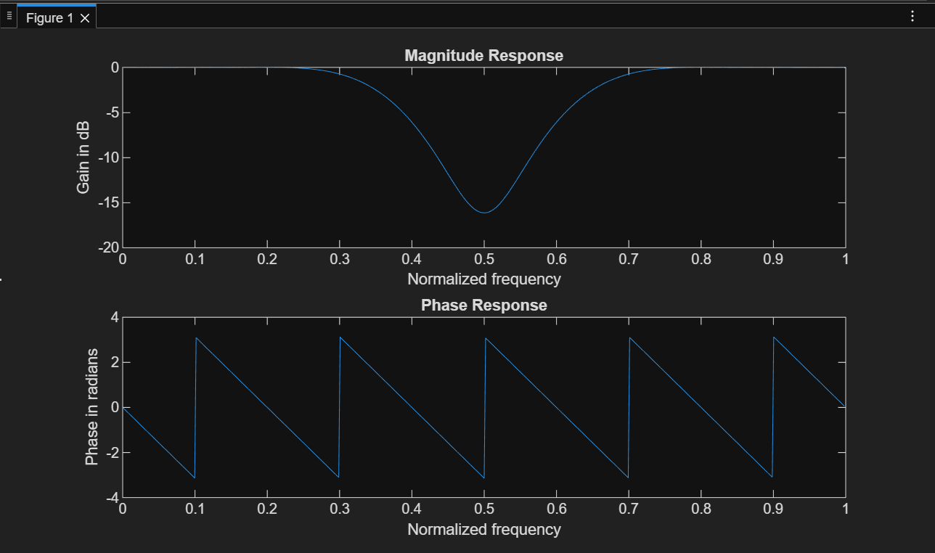
Result:
- FIR filters were successfully designed using different window techniques.
- Magnitude and phase responses varied according to the window used.

Conclusion:
This experiment demonstrated FIR filter design using Rectangular, Bartlett, and Hamming windows. The results showed how window selection affects filter performance in DSP systems.

